Worship Plan for Sunday, March 24, 2019

SHARING OF CONCERNS AND CELEBRATIONS

CONFESSION & FORGIVENESS
Almighty God, to whom all hearts are open, all desires known, and from whom no secrets are hid;
Cleanse the thoughts of our hearts by the inspiration of your Holy Spirit, That we may perfectly love you and worthily magnify your holy name, through Jesus Christ our Lord.
Amen.

If we say we have no sin, we deceive ourselves, and the truth is not in us. But if we confess our sins, God who is faithful and just will forgive our sins and cleanse us from all unrighteousness.

Most merciful God,
We confess that we are in bondage to sin and cannot free ourselves. We have sinned against you in thought, word, and deed, by what we have done and by what we have left undone. We have not loved you with our whole heart; we have not loved our neighbors as ourselves.
For the sake of your Son, Jesus Christ, have mercy on us. Forgive us, renew us, and lead us, so that we may delight in your will and walk in your ways, to the glory of your holy name. Amen.

In the mercy of almighty God, Jesus Christ was given to die for us, and for his sake God forgives us all our sins.
As a called and ordained minister of the Church of Christ, and by his authority, I therefore declare to you the entire forgiveness of all your sins, in the name of the Father, and of the + Son, and of the Holy Spirit. Amen.

GATHERING SONG O Jesus, Joy of Loving Hearts (ELW 658, Vs. 1, 34)

GREETING
The grace of our Lord, Jesus Christ, the love of God,
and the communion of the Holy Spirit be with you all.
And also with you.

PRAYER OF THE DAY
Eternal God, your kingdom has broken into our troubled world through the life, death, and resurrection of your Son. Help us to hear your word and obey it, and bring your saving love to fruition in our lives, through Jesus Christ, our Savior and Lord, who lives and reigns with you and the Holy Spirit, one God, now and forever.
Amen.

Special Music by Laura & Lilly Garey

(The first reading is read by the lay assistant)
THE FIRST READING: Isaiah 55:1-9
A reading from Isaiah.
1 Ho, everyone who thirsts, come to the waters; and you that have no money, come, buy and eat! Come, buy wine and milk without money and without price. ² Why do you spend your money for that which is not bread, and your labor for that which does not satisfy? Listen carefully to me, and eat what is good, and delight yourselves in rich food. ³ Incline your ear, and come to me; listen, so that you may live. I will make with you an everlasting covenant, my steadfast, sure love for David. ⁴ See, I made him a witness to the peoples, a leader and commander for the peoples. ⁵ See, you shall call nations that you do not know, and nations that do not know you shall run to you, because of the Lord your God, the Holy One of Israel, for he has glorified you. ⁶ Seek the Lord while he may be found, call upon him while he is near; ⁷ let the wicked forsake their way, and the unrighteous their thoughts; let them return to the Lord, that he may have mercy on them, and to our God, for he will abundantly pardon. ⁸ For my thoughts are not your thoughts, nor are your ways my ways, says the Lord. ⁹ For as the heavens are higher than the earth, so are my ways higher than your ways and my thoughts than your thoughts.
The reading may be concluded:
Word of God, word of life.
Thanks be to God.

THE SECOND READING: 1 Corinthians 10:1-13
A reading from Paul’s First letter to the Corinthians.
1 I do not want you to be unaware, brothers and sisters, that our ancestors were all under the cloud, and all passed through the sea, ² and all were baptized into Moses in the cloud and in the sea, ³ and all ate the same spiritual food, ⁴ and all drank the same spiritual drink. For they drank from the spiritual rock that followed them, and the rock was Christ. ⁵ Nevertheless, God was not pleased with most of them, and they were struck down in the wilderness. ⁶ Now these things occurred as examples for us, so that we might not desire evil as they did. ⁷ Do not become idolaters as some of them did; as it is written, "The people sat down to eat and drink, and they rose up to play." ⁸ We must not indulge in sexual immorality as some of them did, and twenty-three thousand fell in a single day. ⁹ We must not put Christ to the test, as some of them did, and were destroyed by serpents. ¹⁰ And do not complain as some of them did, and were destroyed by the destroyer. ¹¹ These things happened to them to serve as an example, and they were written down to instruct us, on whom the ends of the ages have come. ¹² So if you think you are standing, watch out that you do not fall. ¹³ No testing has overtaken you that is not common to everyone. God is faithful, and he will not let you be tested beyond your strength, but with the testing he will also provide the way out so that you may be able to endure it.
The reading may be concluded:
Word of God, word of life.
Thanks be to God.

PSALM
We will sing the Psalm for the day.
All of us will sing the refrain, then we will alternate verses as I sing a verse and you sing the next verse back to me using the same tune. The pitch changes are noted in the text by a vertical line.
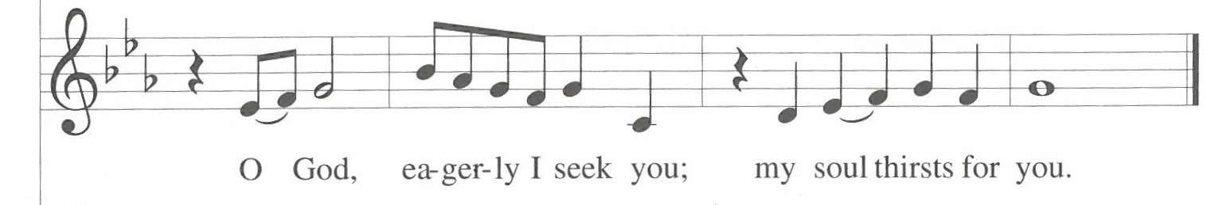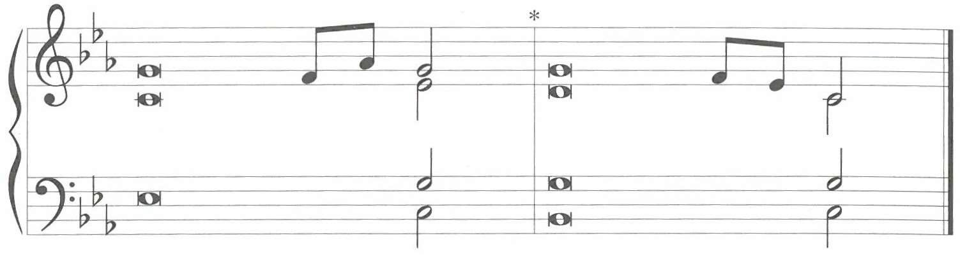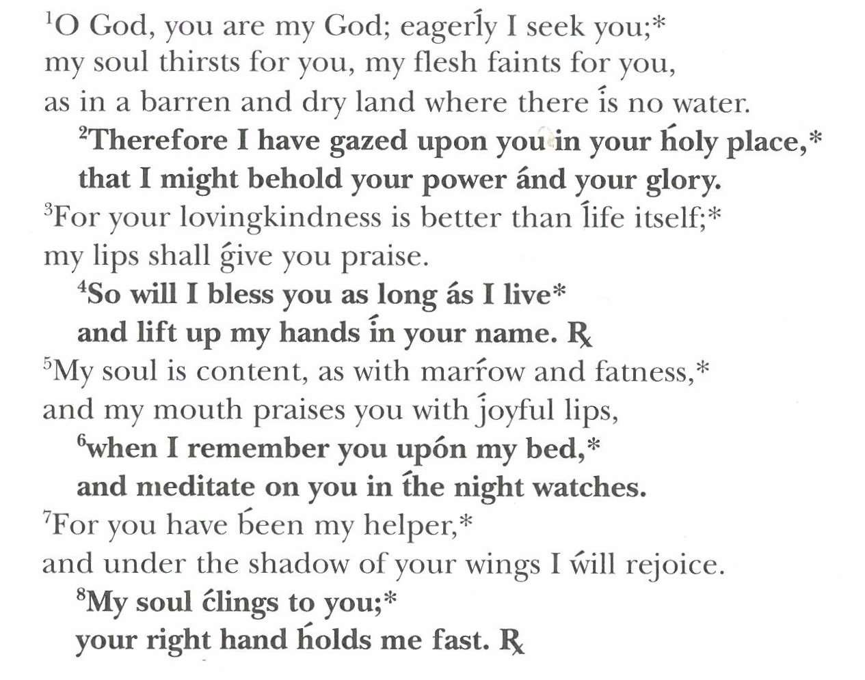

(The gospel is read by the pastor)
GOSPEL: Luke 13:1-9
The gospel is announced.
Please stand as you are able.
Today’s gospel is found in the 13th Chapter of the Book of Luke

The holy gospel according to Luke.
Glory to you, O Lord.
¹ At that very time there were some present who told him about the Galileans whose blood Pilate had mingled with their sacrifices. ² He asked them, "Do you think that because these Galileans suffered in this way they were worse sinners than all other Galileans? ³ No, I tell you; but unless you repent, you will all perish as they did. ⁴ Or those eighteen who were killed when the tower of Siloam fell on them—do you think that they were worse offenders than all the others living in Jerusalem? ⁵ No, I tell you; but unless you repent, you will all perish just as they did." ⁶ Then he told this parable: "A man had a fig tree planted in his vineyard; and he came looking for fruit on it and found none. ⁷ So he said to the gardener, "See here! For three years I have come looking for fruit on this fig tree, and still I find none. Cut it down! Why should it be wasting the soil?' ⁸ He replied, "Sir, let it alone for one more year, until I dig around it and put manure on it. ⁹ If it bears fruit next year, well and good; but if not, you can cut it down.' "
The gospel concludes:
The gospel of the Lord.
Praise to you, O Christ.

CHILDREN’S MESSAGE

HYMN OF THE DAY Jesus, Priceless Treasure (ELW 775)

SERMON

PEACE
The peace of Christ be with you always.
And also with you.

(The pastor reads the introduction and the ending,
the lay assistant reads the indented petitions.)
PRAYERS OF INTERCESSION

Seeking the grace, mercy, and love of almighty God, we offer our prayers for the church, for people in need, and for all of creation.

Holy God, build up the body of Christ and cause the gifts of your Spirit to grow among us. Lead us to recognize your saving work through the spiritual practices you encourage.
Hear us, O God. Your mercy is great.

Water the earth with gentle rains and melting snow. Provide clean water for drinking, washing, and nourishing plants that will bear fruit for your creatures.
Hear us, O God. Your mercy is great.

Uphold people who speak your righteousness in the face of religious or political persecution. Receive martyrs (like Oscar Arnulfo Romero, who we commemorate today) into your everlasting peace.
Hear us, O God. Your mercy is great.

Provide relief for those suffering and in pain (especially). Grant wisdom to health care workers who seek to diagnose ailments, and bring healing to patients.
Hear us, O God. Your mercy is great.

Promote unity within your church and among the nations. Uncover the common threads in our shared humanity, and keep us from making hasty judgements about others.
Hear us, O God. Your mercy is great.

Knit together the communion of saints, and bind us to Christ, our head. Through the diversity of gifts present in our communities, help us to overcome our limitations and increase our understanding of ourselves and others.
Hear us, O God. Your mercy is great.

Reveal your will as you receive our prayers, and conform our ways to your ways, through the saving work of Jesus Christ our Lord.
Amen.

THANKSGIVING AT THE TABLE
In the night in which he was betrayed, our Lord Jesus took bread and gave thanks, broke it, and gave it to his disciples, saying;
“Take and eat; this is my body, given for you. Do this for the remembrance of me.”

Again, after supper, he took the cup, gave thanks, and gave it for all to drink, saying; “This cup is the new covenant in my blood, shed for you and for all people for the forgiveness of sin. Do this for the remembrance of me.”

Remembering, therefore, his life lived for others, and his death and resurrection which renews the face of the earth, we await his coming in glory.

Pour out upon us the Spirit of your love, O Lord, and unite the wills of all who share this heavenly food, the body and blood of Jesus Christ, our Lord; to whom, with you and the Holy Spirit, be all honor and glory, now and forever.
Amen.

LORD’S PRAYER
Gathered into one by the Holy Spirit, let us pray as Jesus taught us.

Our Father, who art in heaven, hallowed be thy name, thy kingdom come, thy will be done, on earth as it is in heaven.

Give us this day our daily bread; and forgive us our trespasses, as we forgive those who trespass against us; and lead us not into temptation, but deliver us from evil.

For thine is the kingdom, and the power, and the glory, forever and ever. Amen.

INVITATION TO COMMUNION
Christ has prepared the feast.
Come to the table where all are welcomed home.
Thanks be to God!

COMMUNION

(The prayer after communion is read by the lay assistant)
PRAYER AFTER COMMUNION

Compassionate God,
You have fed us with the bread of heaven. Sustain us in our Lenten pilgrimage;
may our fasting be hunger for justice, our alms, a making of peace,
and our prayer, the song of grateful hearts; through Christ our Lord.
Amen.

ANNOUNCEMENTS & OFFERING

BLESSING
May God who has called us forth from the dust of the earth,
and claimed us as children of the light, strengthen you on your journey into new life.
Almighty God, Father, Son, + and Holy Spirit bless you, now and forever.
Amen.

SENDING SONG O Living Bread from Heaven (ELW 541), Vs. 1, 2, 4

(The dismissal is given by the lay assistant)
DISMISSAL

Marked with the cross of Christ,
Go forth to love and serve the Lord.
Thanks be to God!

POSTLUDE

