Worship Plan for Sunday, March 31, 2019

SHARING OF CONCERNS AND CELEBRATIONS

CONFESSION & FORGIVENESS
Almighty God, to whom all hearts are open, all desires known, and from whom no secrets are hid;
Cleanse the thoughts of our hearts by the inspiration of your Holy Spirit, That we may perfectly love you and worthily magnify your holy name, through Jesus Christ our Lord.
Amen.

If we say we have no sin, we deceive ourselves, and the truth is not in us. But if we confess our sins, God who is faithful and just will forgive our sins and cleanse us from all unrighteousness.

Most merciful God,
We confess that we are in bondage to sin and cannot free ourselves. We have sinned against you in thought, word, and deed, by what we have done and by what we have left undone. We have not loved you with our whole heart; we have not loved our neighbors as ourselves.
For the sake of your Son, Jesus Christ, have mercy on us. Forgive us, renew us, and lead us, so that we may delight in your will and walk in your ways, to the glory of your holy name. Amen.

In the mercy of almighty God, Jesus Christ was given to die for us, and for his sake God forgives us all our sins.
As a called and ordained minister of the Church of Christ, and by his authority, I therefore declare to you the entire forgiveness of all your sins, in the name of the Father, and of the + Son, and of the Holy Spirit. Amen.

GATHERING SONG God Loved the World (ELW 323, v 1, 2, 5)

GREETING
The grace of our Lord, Jesus Christ, the love of God,
and the communion of the Holy Spirit be with you all.
And also with you.

PRAYER OF THE DAY
God of compassion, you welcome the wayward, and you embrace us all with your mercy. By our baptism clothe us with garments of your grace, and feed us at the table of your love, through Jesus Christ, our Savior and Lord, who lives and reigns with you and the Holy Spirit, one God, now and forever.
Amen.

CHOIR ANTHEM Wondrous Love

(The first reading is read by the lay assistant)
THE FIRST READING: Joshua 5:9-12
A reading from Joshua.
The Lord said to Joshua, “Today I have rolled away from you the disgrace of Egypt.” And so that place is called Gilgal to this day.
¹⁰While the Israelites were camped in Gilgal they kept the passover in the evening on the fourteenth day of the month in the plains of Jericho. ¹¹On the day after the passover, on that very day, they ate the produce of the land, unleavened cakes and parched grain. ¹²The manna ceased on the day they ate the produce of the land, and the Israelites no longer had manna; they ate the crops of the land of Canaan that year.

The reading may be concluded:
Word of God, word of life.
Thanks be to God.

THE SECOND READING: 2 Corinthians 5:16-21
A reading from Paul’s Second letter to the Corinthians.
¹⁶From now on, therefore, we regard no one from a human point of view; even though we once knew Christ from a human point of view, we know him no longer in that way. ¹⁷So if anyone is in Christ, there is a new creation: everything old has passed away; see, everything has become new! ¹⁸All this is from God, who reconciled us to himself through Christ, and has given us the ministry of reconciliation; ¹⁹that is, in Christ God was reconciling the world to himself, not counting their trespasses against them, and entrusting the message of reconciliation to us. ²⁰So we are ambassadors for Christ, since God is making his appeal through us; we entreat you on behalf of Christ, be reconciled to God. ²¹For our sake he made him to be sin who knew no sin, so that in him we might become the righteousness of God.

The reading may be concluded:
Word of God, word of life.
Thanks be to God.

PSALM
We will sing the Psalm for the day. All of us will sing the refrain, then we will alternate verses as I sing a verse and you sing the next verse back to me using the same tune. The pitch changes are noted in the text by a vertical line.

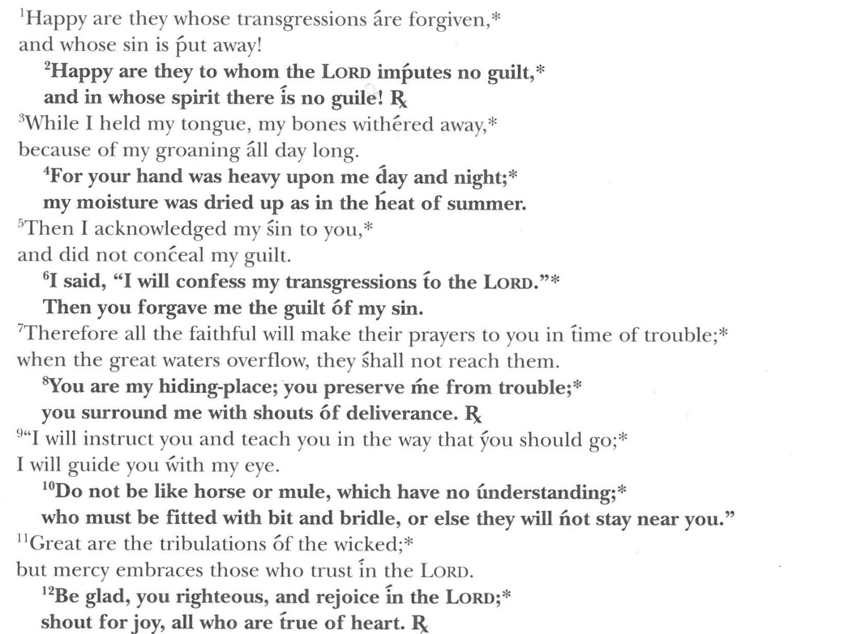
GOSPEL: Luke 15:1-3, 11b-32
Please stand as you are able. Today’s gospel is found in the 15th Chapter of the Book of Luke
The holy gospel according to Luke. Glory to you, O Lord.
Now all the tax collectors and sinners were coming near to listen to him. ²And the Pharisees and the scribes were grumbling and saying, “This fellow welcomes sinners and eats with them.” ³So he told them this parable:
“There was a man who had two sons. ¹²The younger of them said to his father, ‘Father, give me the share of the property that will belong to me.’ So he divided his property between them. ¹³A few days later the younger son gathered all he had and traveled to a distant country, and there he squandered his property in dissolute living. ¹⁴When he had spent everything, a severe famine took place throughout that country, and he began to be in need. ¹⁵So he went and hired himself out to one of the citizens of that country, who sent him to his fields to feed the pigs. ¹⁶He would gladly have filled himself with the pods that the pigs were eating; and no one gave him anything. ¹⁷But when he came to himself he said, ‘How many of my father’s hired hands have bread enough and to spare, but here I am dying of hunger! ¹⁸I will get up and go to my father, and I will say to him, “Father, I have sinned against heaven and before you; ¹⁹I am no longer worthy to be called your son; treat me like one of your hired hands.”’ ²⁰So he set off and went to his father. But while he was still far off, his father saw him and was filled with compassion; he ran and put his arms around him and kissed him. ²¹Then the son said to him, ‘Father, I have sinned against heaven and before you; I am no longer worthy to be called your son.’ ²²But the father said to his slaves, ‘Quickly, bring out a robe—the best one—and put it on him; put a ring on his finger and sandals on his feet. ²³And get the fatted calf and kill it, and let us eat and celebrate; ²⁴for this son of mine was dead and is alive again; he was lost and is found!’ And they began to celebrate. ²⁵“Now his elder son was in the field; and when he came and approached the house, he heard music and dancing. ²⁶He called one of the slaves and asked what was going on. ²⁷He replied, ‘Your brother has come, and your father has killed the fatted calf, because he has got him back safe and sound.’ ²⁸Then he became angry and refused to go in. His father came out and began to plead with him. ²⁹But he answered his father, ‘Listen! For all these years I have been working like a slave for you, and I have never disobeyed your command; yet you have never given me even a young goat so that I might celebrate with my friends. ³⁰But when this son of yours came back, who has devoured your property with prostitutes, you killed the fatted calf for him!’ ³¹Then the father said to him, ‘Son, you are always with me, and all that is mine is yours. ³²But we had to celebrate and rejoice, because this brother of yours was dead and has come to life; he was lost and has been found.’”
The gospel concludes:
The gospel of the Lord.
Praise to you, O Christ.

CHILDREN’S MESSAGE

HYMN OF THE DAY Our Father, We Have Wandered (ELW 606)

SERMON

PEACE
The peace of Christ be with you always.
And also with you.

(The pastor reads the introduction and the ending,
the lay assistant reads the indented petitions.)
PRAYERS OF INTERCESSION

Seeking the grace, mercy, and love of almighty God, we offer our prayers for the church, for people in need, and for all of creation.

God of abundant grace, guide your church to look upon people as you look upon them, with compassion and as deserving of mercy. Shape us to be worthy ambassadors of Christ.
Hear us, O God. Your mercy is great.

Bestow dignity on migrant and seasonal farm and factory workers. When the time comes for them to leave jobs, provide new ways for them to make a livelihood.
Hear us, O God. Your mercy is great.

Inspire musicians and poets to point to your unfathomable beauty and creativity. Enhance our vision of your holiness through their works.
Hear us, O God. Your mercy is great.

Protect and preserve all people who look to you to be their hiding place, especially…. Be their respite from trouble, and give themhope.
Hear us, O God. Your mercy is great.

Erase the pain of trauma and the shame and stigma of social contempt. Change the hearts of those who bully or mistreat others, and heal broken relationships.
Hear us, O God. Your mercy is great.

Invite your whole company of saints into eternal, joyful feasting. When we question your abundant mercy, soften our hearts to receive the gifts of faith and love.
Hear us, O God. Your mercy is great.

Reveal your will as you receive our prayers, and conform our ways to your ways, through the saving work of Jesus Christ our Lord.
Amen.

THANKSGIVING AT THE TABLE
In the night in which he was betrayed, our Lord Jesus took bread and gave thanks, broke it, and gave it to his disciples, saying;
“Take and eat; this is my body, given for you. Do this for the remembrance of me.”

Again, after supper, he took the cup, gave thanks, and gave it for all to drink, saying; “This cup is the new covenant in my blood, shed for you and for all people for the forgiveness of sin. Do this for the remembrance of me.”

Remembering, therefore, his life lived for others, and his death and resurrection which renews the face of the earth, we await his coming in glory.

Pour out upon us the Spirit of your love, O Lord, and unite the wills of all who share this heavenly food, the body and blood of Jesus Christ, our Lord; to whom, with you and the Holy Spirit, be all honor and glory, now and forever.
Amen.

LORD’S PRAYER
Gathered into one by the Holy Spirit, let us pray as Jesus taught us.

Our Father, who art in heaven, hallowed be thy name, thy kingdom come, thy will be done, on earth as it is in heaven.

Give us this day our daily bread; and forgive us our trespasses, as we forgive those who trespass against us; and lead us not into temptation, but deliver us from evil.

For thine is the kingdom, and the power, and the glory, forever and ever. Amen.

INVITATION TO COMMUNION
Christ has prepared the feast.
Come to the table where all are welcomed home.
Thanks be to God!

COMMUNION

(The prayer after communion is read by the lay assistant)
PRAYER AFTER COMMUNION
Compassionate God,
You have fed us with the bread of heaven. Sustain us in our Lenten pilgrimage;
may our fasting be hunger for justice, our alms, a making of peace,
and our prayer, the song of grateful hearts; through Christ our Lord.
Amen.

ANNOUNCEMENTS & OFFERING

BLESSING
May God who has called us forth from the dust of the earth,
and claimed us as children of the light, strengthen you on your journey into new life.
Almighty God, Father, Son, + and Holy Spirit bless you, now and forever.
Amen.

SENDING SONG God, When Human Bonds are Broken (ELW 603, vs. 1, 2, 5)

(The dismissal is given by the lay assistant)
DISMISSAL
Marked with the cross of Christ,
Go forth to love and serve the Lord. Thanks be to God!

POSTLUDE

