Worship Plan for Sunday, April 7, 2019

SHARING OF CONCERNS AND CELEBRATIONS

CONFESSION & FORGIVENESS
Almighty God, to whom all hearts are open, all desires known, and from whom no secrets are hid;
Cleanse the thoughts of our hearts by the inspiration of your Holy Spirit, That we may perfectly love you and worthily magnify your holy name, through Jesus Christ our Lord.
Amen.

If we say we have no sin, we deceive ourselves, and the truth is not in us. But if we confess our sins, God who is faithful and just will forgive our sins and cleanse us from all unrighteousness.

Most merciful God,
We confess that we are in bondage to sin and cannot free ourselves. We have sinned against you in thought, word, and deed, by what we have done and by what we have left undone. We have not loved you with our whole heart; we have not loved our neighbors as ourselves.
For the sake of your Son, Jesus Christ, have mercy on us. Forgive us, renew us, and lead us, so that we may delight in your will and walk in your ways, to the glory of your holy name. Amen.

In the mercy of almighty God, Jesus Christ was given to die for us, and for his sake God forgives us all our sins.
As a called and ordained minister of the Church of Christ, and by his authority, I therefore declare to you the entire forgiveness of all your sins, in the name of the Father, and of the + Son, and of the Holy Spirit. Amen.

GATHERING SONG Christ, the Life of All the Living (ELW 339)

GREETING
The grace of our Lord, Jesus Christ, the love of God,
and the communion of the Holy Spirit be with you all.
And also with you.

PRAYER OF THE DAY
Creator God, you prepare a new way in the wilderness, and your grace waters our desert. Open our hearts to be transformed by the new thing you are doing, that our lives may proclaim the extravagance of your love given to all through your Son, Jesus Christ, our Savior and Lord, who lives and reigns with you and the Holy Spirit, one God, now and forever.
Amen.

CHOIR ANTHEM Unless a Grain of Wheat Falls (Marty Haugen)

(The first reading is read by the lay assistant)
THE FIRST READING: Isaiah 43:16-21
A reading from Isaiah.
¹⁶Thus says the Lord, who makes a way in the sea, a path in the mighty waters,

¹⁷who brings out chariot and horse, army and warrior; they lie down, they cannot rise, they are extinguished, quenched like a wick:

¹⁸Do not remember the former things, or consider the things of old.

¹⁹I am about to do a new thing; now it springs forth, do you not perceive it? I will make a way in the wilderness and rivers in the desert.

²⁰The wild animals will honor me, the jackals and the ostriches; for I give water in the wilderness, rivers in the desert, to give drink to my chosen people,

²¹the people whom I formed for myself so that they might declare my praise.

The reading may be concluded:
Word of God, word of life.
Thanks be to God.

THE SECOND READING: Philippians 3:4b-14
A reading from Paul’s Letter to the Philippians.
If anyone else has reason to be confident in the flesh, I have more:
⁵circumcised on the eighth day, a member of the people of Israel, of the tribe of Benjamin, a Hebrew born of Hebrews; as to the law, a Pharisee;
⁶as to zeal, a persecutor of the church; as to righteousness under the law, blameless.
⁷Yet whatever gains I had, these I have come to regard as loss because of Christ.
⁸More than that, I regard everything as loss because of the surpassing value of knowing Christ Jesus my Lord. For his sake I have suffered the loss of all things, and I regard them as rubbish, in order that I may gain Christ
⁹and be found in him, not having a righteousness of my own that comes from the law, but one that comes through faith in Christ, the righteousness from God based on faith.
¹⁰I want to know Christ and the power of his resurrection and the sharing of his sufferings by becoming like him in his death,
¹¹if somehow I may attain the resurrection from the dead.
¹²Not that I have already obtained this or have already reached the goal; but I press on to make it my own, because Christ Jesus has made me his own.
¹³Beloved, I do not consider that I have made it my own; but this one thing I do: forgetting what lies behind and straining forward to what lies ahead,
¹⁴I press on toward the goal for the prize of the heavenly call of God in Christ Jesus.
The reading may be concluded:
Word of God, word of life.
Thanks be to God.

PSALM
We will sing the Psalm for the day. All of us will sing the refrain, then we will alternate verses as I sing a verse and you sing the next verse back to me using the same tune. The pitch changes are noted in the text by a vertical line.
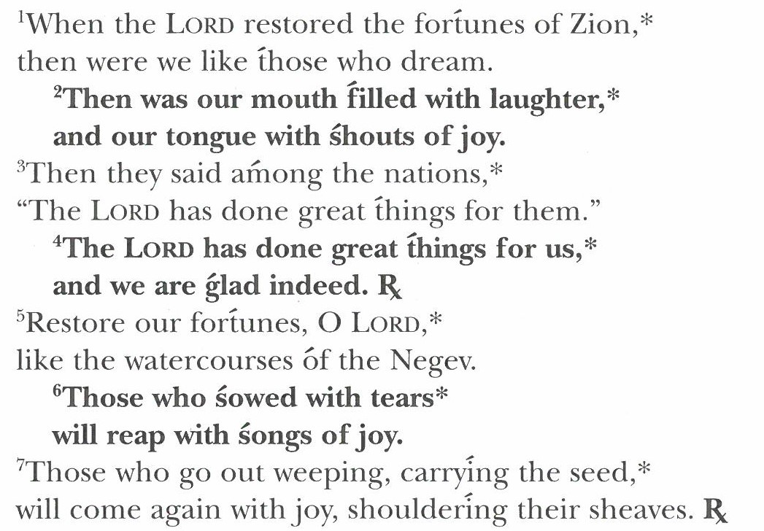
GOSPEL: John 12:1-8

Please stand as you are able. Today’s gospel is found in the 15th Chapter of the Book of Luke
The holy gospel according to Luke. Glory to you, O Lord.
12Six days before the Passover Jesus came to Bethany, the home of Lazarus, whom he had raised from the dead. ²There they gave a dinner for him. Martha served, and Lazarus was one of those at the table with him.

³Mary took a pound of costly perfume made of pure nard, anointed Jesus’ feet, and wiped them with her hair. The house was filled with the fragrance of the perfume.

⁴But Judas Iscariot, one of his disciples (the one who was about to betray him), said, ⁵“Why was this perfume not sold for three hundred denarii and the money given to the poor?”

⁶(He said this not because he cared about the poor, but because he was a thief; he kept the common purse and used to steal what was put into it.)

⁷Jesus said, “Leave her alone. She bought it so that she might keep it for the day of my burial. ⁸You always have the poor with you, but you do not always have me.”

The gospel concludes:
The gospel of the Lord.
Praise to you, O Christ.

CHILDREN’S MESSAGE

HYMN OF THE DAY Be Thou My Vision (ELW 793, Vs. 1, 2, 4)

SERMON

PEACE
The peace of Christ be with you always.
And also with you.

(The pastor reads the introduction and the ending,
the lay assistant reads the indented petitions.)
PRAYERS OF INTERCESSION

Seeking the grace, mercy, and love of almighty God, we offer our prayers for the church, for people in need, and for all of creation.

God of resurrection and new life, inspire your church to reconsider what makes us holy. When we focus on our own piety or others’ sin, show us Christ’s faithfulness.
Hear us, O God. Your mercy is great.

Wherever destruction by floor, famine, or fire has devastated land and lives, cause green shoots to spring up, giving hope and vision for your promised future.
Hear us, O God. Your mercy is great.

Where nations are embroiled in chaos and unrest, cut a clear path for your people to follow. Lead us in ways of reconciliation, and foretell the new things you prepare.
Hear us, O God. Your mercy is great.

Wipe away the tears of those who weep under the burdens of hard labor and despair…especially…. Restore them, and bring them into the joy of your presence.
Hear us, O God. Your mercy is great.

Permeate the world with the sweet perfume of Christ’s anointing. Fill your people with such gratitude that it spills over into service towards those who are poor or in any need.
Hear us, O God. Your mercy is great.

Accompany those for whom death draws near. Bring us with all your saints to receive the abundance of heavenly glory through the covenant Christ sealed in his death and resurrection.
Hear us, O God. Your mercy is great.

Reveal your will as you receive our prayers, and conform our ways to your ways, through the saving work of Jesus Christ our Lord.
Amen.

THANKSGIVING AT THE TABLE
In the night in which he was betrayed, our Lord Jesus took bread and gave thanks, broke it, and gave it to his disciples, saying;
“Take and eat; this is my body, given for you. Do this for the remembrance of me.”

Again, after supper, he took the cup, gave thanks, and gave it for all to drink, saying; “This cup is the new covenant in my blood, shed for you and for all people for the forgiveness of sin. Do this for the remembrance of me.”

Remembering, therefore, his life lived for others, and his death and resurrection which renews the face of the earth, we await his coming in glory.

Pour out upon us the Spirit of your love, O Lord, and unite the wills of all who share this heavenly food, the body and blood of Jesus Christ, our Lord; to whom, with you and the Holy Spirit, be all honor and glory, now and forever.
Amen.

LORD’S PRAYER
Gathered into one by the Holy Spirit, let us pray as Jesus taught us.

Our Father, who art in heaven, hallowed be thy name, thy kingdom come, thy will be done, on earth as it is in heaven.

Give us this day our daily bread; and forgive us our trespasses, as we forgive those who trespass against us; and lead us not into temptation, but deliver us from evil.

For thine is the kingdom, and the power, and the glory, forever and ever. Amen.

INVITATION TO COMMUNION
Christ has prepared the feast.
Come to the table where all are welcomed home.
Thanks be to God!

COMMUNION

(The prayer after communion is read by the lay assistant)
PRAYER AFTER COMMUNION
Compassionate God,
You have fed us with the bread of heaven. Sustain us in our Lenten pilgrimage;
may our fasting be hunger for justice, our alms, a making of peace,
and our prayer, the song of grateful hearts; through Christ our Lord.
Amen.

ANNOUNCEMENTS & OFFERING

BLESSING
May God who has called us forth from the dust of the earth,
and claimed us as children of the light, strengthen you on your journey into new life.
Almighty God, Father, Son, + and Holy Spirit bless you, now and forever.
Amen.

SENDING SONG Lead On, O King Eternal (ELW 805)

(The dismissal is given by the lay assistant)
DISMISSAL
Marked with the cross of Christ,
Go forth to love and serve the Lord. Thanks be to God!

POSTLUDE

