Worship Plan for Sunday, March 10, 2019

SHARING OF CONCERNS AND CELEBRATIONS

CONFESSION & FORGIVENESS
Almighty God, to whom all hearts are open,
all desires known, and from whom no secrets are hid;
Cleanse the thoughts of our hearts by the inspiration of your Holy Spirit,
That we may perfectly love you and worthily magnify your holy name,
through Jesus Christ our Lord.
Amen.

If we say we have no sin, we deceive ourselves, and the truth is not in us.
But if we confess our sins, God who is faithful and just will forgive our sins
and cleanse us from all unrighteousness.

Most merciful God,
We confess that we are in bondage to sin and cannot free ourselves.
We have sinned against you in thought, word, and deed,
by what we have done and by what we have left undone.
We have not loved you with our whole heart;
we have not loved our neighbors as ourselves.
For the sake of your Son, Jesus Christ, have mercy on us.
Forgive us, renew us, and lead us,
so that we may delight in your will and walk in your ways,
to the glory of your holy name. Amen.

In the mercy of almighty God, Jesus Christ was given to die for us,
and for his sake God forgives us all our sins.
As a called and ordained minister of the Church of Christ, and by his authority,
I therefore declare to you the entire forgiveness of all your sins,
in the name of the Father, and of the + Son, and of the Holy Spirit.
Amen.

GATHERING SONG Eternal Lord of Love (ELW 321)

GREETING
The grace of our Lord, Jesus Christ, the love of God,
and the communion of the Holy Spirit be with you all.
And also with you.

PRAYER OF THE DAY
O Lord God, you led your people through the wilderness and brought them to the promised land. Guide us now, so that, following your Son, we may walk safely through the wilderness of this world toward the life you alone can give, through Jesus Christ, our Savior and Lord, who lives and reigns with you and the Holy Spirit, one God, now and forever.
Amen.

CHOIR ANTHEM Bought with a Price, Natalie Sleeth

(The first reading is read by the lay assistant)
THE FIRST READING: Deuteronomy 26:1-11

The spring harvest festival, called the Feast of Weeks, provides the setting for this reading. This festival celebrates the first fruits of the produce of the land offered back to God in thanks. In this text, worshipers announce God’s gracious acts on behalf of Israel.

A reading from Deuteronomy.

26When you have come into the land that the Lord your God is giving you as an inheritance to possess, and you possess it, and settle in it, ²you shall take some of the first of all the fruit of the ground, which you harvest from the land that the Lord your God is giving you, and you shall put it in a basket and go to the place that the Lord your God will choose as a dwelling for his name. ³You shall go to the priest who is in office at that time, and say to him, “Today I declare to the Lord your God that I have come into the land that the Lord swore to our ancestors to give us.” ⁴When the priest takes the basket from your hand and sets it down before the altar of the Lord your God, ⁵you shall make this response before the Lord your God: “A wandering Aramean was my ancestor; he went down into Egypt and lived there as an alien, few in number, and there he became a great nation, mighty and populous. ⁶When the Egyptians treated us harshly and afflicted us, by imposing hard labor on us, ⁷we cried to the Lord, the God of our ancestors; the Lord heard our voice and saw our affliction, our toil, and our oppression. ⁸The Lord brought us out of Egypt with a mighty hand and an outstretched arm, with a terrifying display of power, and with signs and wonders; ⁹and he brought us into this place and gave us this land, a land flowing with milk and honey. ¹⁰So now I bring the first of the fruit of the ground that you, O Lord, have given me.” You shall set it down before the Lord your God and bow down before the Lord your God. ¹¹Then you, together with the Levites and the aliens who reside among you, shall celebrate with all the bounty that the Lord your God has given to you and to your house.

The reading may be concluded:
Word of God, word of life.
Thanks be to God.

THE Second READING: Romans 10:8b-13

Paul reminds the Christians in Rome of the foundation of their creed, the confession of faith in the risen Christ as Lord.

A reading from Romans.

“The word is near you, on your lips and in your heart” (that is, the word of faith that we proclaim); ⁹because if you confess with your lips that Jesus is Lord and believe in your heart that God raised him from the dead, you will be saved. ¹⁰For one believes with the heart and so is justified, and one confesses with the mouth and so is saved. ¹¹The scripture says, “No one who believes in him will be put to shame.”
¹²For there is no distinction between Jew and Greek; the same Lord is Lord of all and is generous to all who call on him. ¹³For, “Everyone who calls on the name of the Lord shall be saved.”

The reading may be concluded:
Word of God, word of life.
Thanks be to God.

PSALM
We will sing the Psalm for the day.
All of us will sing the refrain, then we will alternate verses as I sing a verse and you sing the next verse back to me using the same tune. The pitch changes are noted in the text by a vertical line.
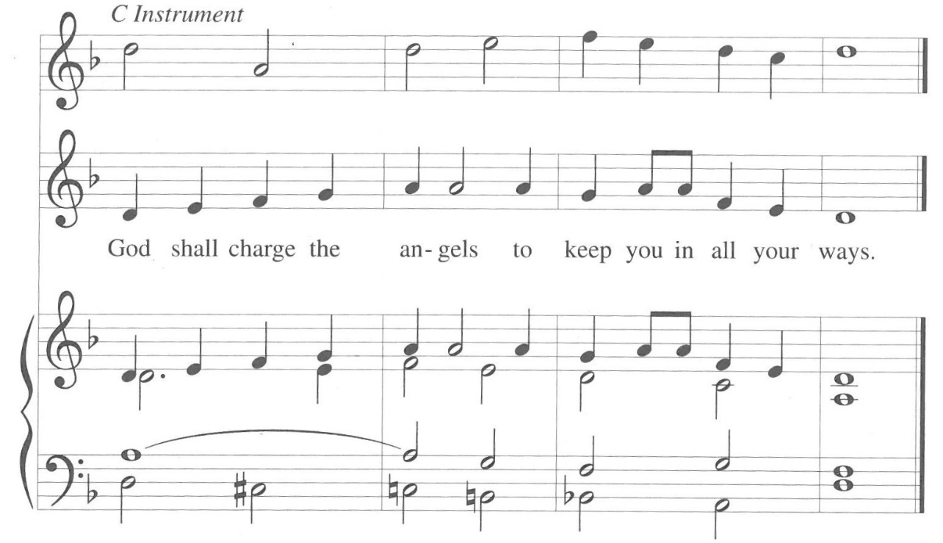

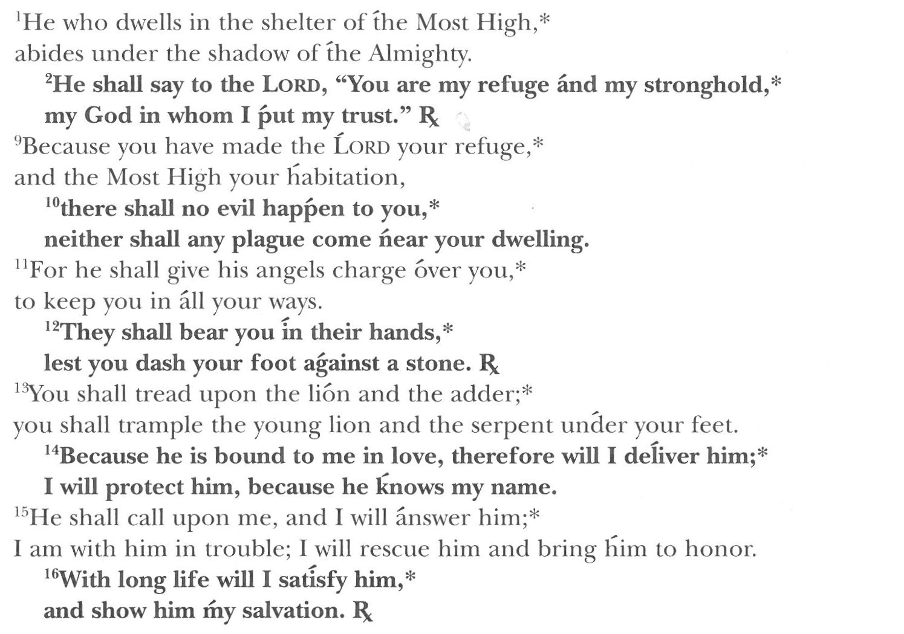
Gospel is read by the pastor)
GOSPEL: Luke 4:1-13

Today’s gospel is found in the 4th Chapter of the Book of Luke

After being filled with the Holy Spirit at his baptism, Jesus is led in the wilderness. Through his responses to the temptations of the devil, he defines what it means to be called “the Son of God.”

The gospel is announced.
The holy gospel according to St. Luke.
Glory to you, O Lord.

4Jesus, full of the Holy Spirit, returned from the Jordan and was led by the Spirit in the wilderness, ²where for forty days he was tempted by the devil. He ate nothing at all during those days, and when they were over, he was famished. ³The devil said to him, “If you are the Son of God, command this stone to become a loaf of bread.” ⁴Jesus answered him, “It is written, ‘One does not live by bread alone.’” ⁵Then the devil led him up and showed him in an instant all the kingdoms of the world. ⁶And the devil said to him, “To you I will give their glory and all this authority; for it has been given over to me, and I give it to anyone I please. ⁷If you, then, will worship me, it will all be yours.” ⁸Jesus answered him, “It is written, ‘Worship the Lord your God, and serve only him.’” ⁹Then the devil took him to Jerusalem, and placed him on the pinnacle of the temple, saying to him, “If you are the Son of God, throw yourself down from here, ¹⁰for it is written, ‘He will command his angels concerning you, to protect you,’ ¹¹and ‘On their hands they will bear you up, so that you will not dash your foot against a stone.’” ¹²Jesus answered him, “It is said, ‘Do not put the Lord your God to the test.’” ¹³When the devil had finished every test, he departed from him until an opportune time.

The gospel concludes:
The gospel of the Lord.
Praise to you, O Christ.

CHILDREN’S MESSAGE

HYMN OF THE DAY As the Deer Runs to the River (ELW 331, vs 1, 2, 4)

SERMON

PEACE
The peace of Christ be with you always.
And also with you.

(The pastor reads the introduction and the ending,
the lay assistant reads the indented petitions.)
PRAYERS OF INTERCESSION

Seeking the grace, mercy, and love of almighty God, we offer our prayers for the church, for people in need, and for all of creation.

Holy and steadfast God, keep your word near to us, planting in our hearts and communities. Make it blossom into proclamation for all people to receive.
Hear us, O God.
Your mercy is great.

As you give your Spirit freely, so also give bread that sustains every living thing. Graciously feed hungry souls and hungry stomachs with your bountiful provision.
Hear us, O God.
Your mercy is great.

Stir up courage among your people to resist oppressive powers and to lead people into freedom, as you did through Harriet Tubman and Sojourner Truth, whom we commemorate today. Shine the light of your justice through their work.
Hear us, O God.
Your mercy is great.

Hold tightly those who9 grow weary in their struggle with addiction or temptation. By your strength bear them up to live fully in your presence.
Hear us, O God.
Your mercy is great.

Teach us the stories of our faith by heart. As you accompanied our ancestors in their uncertainty, so guide us confidently into the future.
Hear us, O God.
Your mercy is great.
When we struggle and are tested, redeem us by the endurance of Christ. Give us steadfast faith to strive for your glory until we witness its fullness.
Hear us, O God.
Your mercy is great.

Reveal your will as you receive our prayers, and conform our ways to your ways, through the saving work of Jesus Christ our Lord.
Amen.

THANKSGIVING AT THE TABLE
In the night in which he was betrayed, our Lord Jesus took bread and gave thanks,
broke it, and gave it to his disciples, saying;
“Take and eat; this is my body, given for you. Do this for the remembrance of me.”

Again, after supper, he took the cup, gave thanks, and gave it for all to drink, saying;
“This cup is the new covenant in my blood, shed for you and for all people for the forgiveness of sin. Do this for the remembrance of me.”

Remembering, therefore, his life lived for others, and his death and resurrection which renews the face of the earth, we await his coming in glory.

Pour out upon us the Spirit of your love, O Lord, and unite the wills of all who share this heavenly food, the body and blood of Jesus Christ, our Lord; to whom, with you and the Holy Spirit, be all honor and glory, now and forever.
Amen.

LORD’S PRAYER
Gathered into one by the Holy Spirit, let us pray as Jesus taught us.

Our Father, who art in heaven, hallowed be thy name,
thy kingdom come, thy will be done, on earth as it is in heaven.

Give us this day our daily bread;
and forgive us our trespasses, as we forgive those who trespass against us;
and lead us not into temptation, but deliver us from evil.

For thine is the kingdom, and the power, and the glory, forever and ever.
Amen.

INVITATION TO COMMUNION
Return to God with all your heart.
Receive bread for the journey, drink for the desert.
Thanks be to God!

COMMUNION

(The prayer after communion is read by the lay assistant)
PRAYER AFTER COMMUNION

Compassionate God,
You have fed us with the bread of heaven. Sustain us in our Lenten pilgrimage;
may our fasting be hunger for justice, our alms, a making of peace,
and our prayer, the song of grateful hearts; through Christ our Lord.
Amen.

ANNOUNCEMENTS & OFFERING

Blessing
May God who has called us forth from the dust of the earth,
and claimed us as children of the light, strengthen you on your journey into new life.
Almighty God, Father, Son, + and Holy Spirit bless you, now and forever.
Amen.

Sending Song Guide Me Ever, Great Jehovah (ELW 618)

(The dismissal is given by the lay assistant)
DISMISSAL
Marked with the cross of Christ,
Go forth to love and serve the Lord.
Thanks be to God!

Copyright © 2016 Augsburg Fortress. All rights reserved. Reprinted by permission under Augsburg Fortress Liturgies Annual License #SAS000806.
New Revised Standard Version Bible, copyright © 1989,
Division of Christian Education of the National Council of the Churches of Christ in the United States of America.
Used by permission. All rights reserved.

