Worship Plan for Sunday, March 17, 2019

SHARING OF CONCERNS AND CELEBRATIONS

CONFESSION & FORGIVENESS
Almighty God, to whom all hearts are open,
all desires known, and from whom no secrets are hid;
Cleanse the thoughts of our hearts by the inspiration of your Holy Spirit,
That we may perfectly love you and worthily magnify your holy name,
through Jesus Christ our Lord.
Amen.

If we say we have no sin, we deceive ourselves, and the truth is not in us.
But if we confess our sins, God who is faithful and just will forgive our sins
and cleanse us from all unrighteousness.

Most merciful God,
We confess that we are in bondage to sin and cannot free ourselves.
We have sinned against you in thought, word, and deed,
by what we have done and by what we have left undone.
We have not loved you with our whole heart;
we have not loved our neighbors as ourselves.
For the sake of your Son, Jesus Christ, have mercy on us.
Forgive us, renew us, and lead us,
so that we may delight in your will and walk in your ways,
to the glory of your holy name. Amen.

In the mercy of almighty God, Jesus Christ was given to die for us,
and for his sake God forgives us all our sins.
As a called and ordained minister of the Church of Christ, and by his authority,
I therefore declare to you the entire forgiveness of all your sins,
in the name of the Father, and of the + Son, and of the Holy Spirit.
Amen.

GATHERING SONG O Lord Throughout These Forty Days (ELW 319, Vs 1, 2, 4)
GREETING
The grace of our Lord, Jesus Christ, the love of God,
and the communion of the Holy Spirit be with you all.
And also with you.

PRAYER OF THE DAY
God of the covenant, in the mystery of the cross you promise everlasting life to the world. Gather all peoples into your arms, and shelter us with your mercy, that we may rejoice in the life we share in your Son, Jesus Christ, our Savior and Lord, who lives and reigns with you and the Holy Spirit, one God, now and forever
Amen.

CHOIR ANTHEM Return to God, Marty Haugen

(The first reading is read by the lay assistant)
THE FIRST READING: Genesis 15:1-12, 17-18

God promises a childless and doubting Abram that he will have a son, that his descendants will be as numerous as the stars, and that the land of Canaan will be their inheritance. Abram’s trust in God is sealed with a covenant-making ceremony, a sign of God’s promise.

A reading from Genesis.
After these things the word of the Lord came to Abram in a vision, “Do not be afraid, Abram, I am your shield; your reward shall be very great.”
²But Abram said, “O Lord God, what will you give me, for I continue childless, and the heir of my house is Eliezer of Damascus?” ³And Abram said, “You have given me no offspring, and so a slave born in my house is to be my heir.” ⁴But the word of the Lord came to him, “This man shall not be your heir; no one but your very own issue shall be your heir.” ⁵He brought him outside and said, “Look toward heaven and count the stars, if you are able to count them.” Then he said to him, “So shall your descendants be.” ⁶And he believed the Lord; and the Lord reckoned it to him as righteousness.
⁷Then he said to him, “I am the Lord who brought you from Ur of the Chaldeans, to give you this land to possess.” ⁸But he said, “O Lord God, how am I to know that I shall possess it?” ⁹He said to him, “Bring me a heifer three years old, a female goat three years old, a ram three years old, a turtledove, and a young pigeon.” ¹⁰He brought him all these and cut them in two, laying each half over against the other; but he did not cut the birds in two. ¹¹And when birds of prey came down on the carcasses, Abram drove them away.
¹²As the sun was going down, a deep sleep fell upon Abram, and a deep and terrifying darkness descended upon him.
¹⁷When the sun had gone down and it was dark, a smoking fire pot and a flaming torch passed between these pieces. ¹⁸On that day the Lord made a covenant with Abram, saying, “To your descendants I give this land, from the river of Egypt to the great river, the river Euphrates.

The reading may be concluded:
Word of God, word of life.
Thanks be to God.

THE Second READING: Philippians 3:17-4:1

Although Paul’s devotion to Christ has caused him to be persecuted, he does not regret the course he’s taken. Writing from prison, he expresses confidence in a glorious future and encourages other Christians to follow in his footsteps.

A reading from Philippians.

¹⁷Brothers and sisters, join in imitating me, and observe those who live according to the example you have in us. ¹⁸For many live as enemies of the cross of Christ; I have often told you of them, and now I tell you even with tears. ¹⁹Their end is destruction; their god is the belly; and their glory is in their shame; their minds are set on earthly things. ²⁰But our citizenship is in heaven, and it is from there that we are expecting a Savior, the Lord Jesus Christ. ²¹He will transform the body of our humiliation that it may be conformed to the body of his glory, by the power that also enables him to make all things subject to himself.
4Therefore, my brothers and sisters, whom I love and long for, my joy and crown, stand firm in the Lord in this way, my beloved.

The reading may be concluded:
Word of God, word of life.
Thanks be to God.

PSALM
We will sing the Psalm for the day.
All of us will sing the refrain, then we will alternate verses as I sing a verse and you sing the next verse back to me using the same tune. The pitch changes are noted in the text by a vertical line.
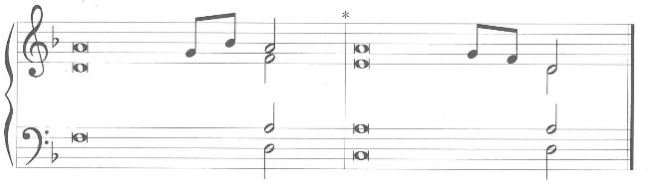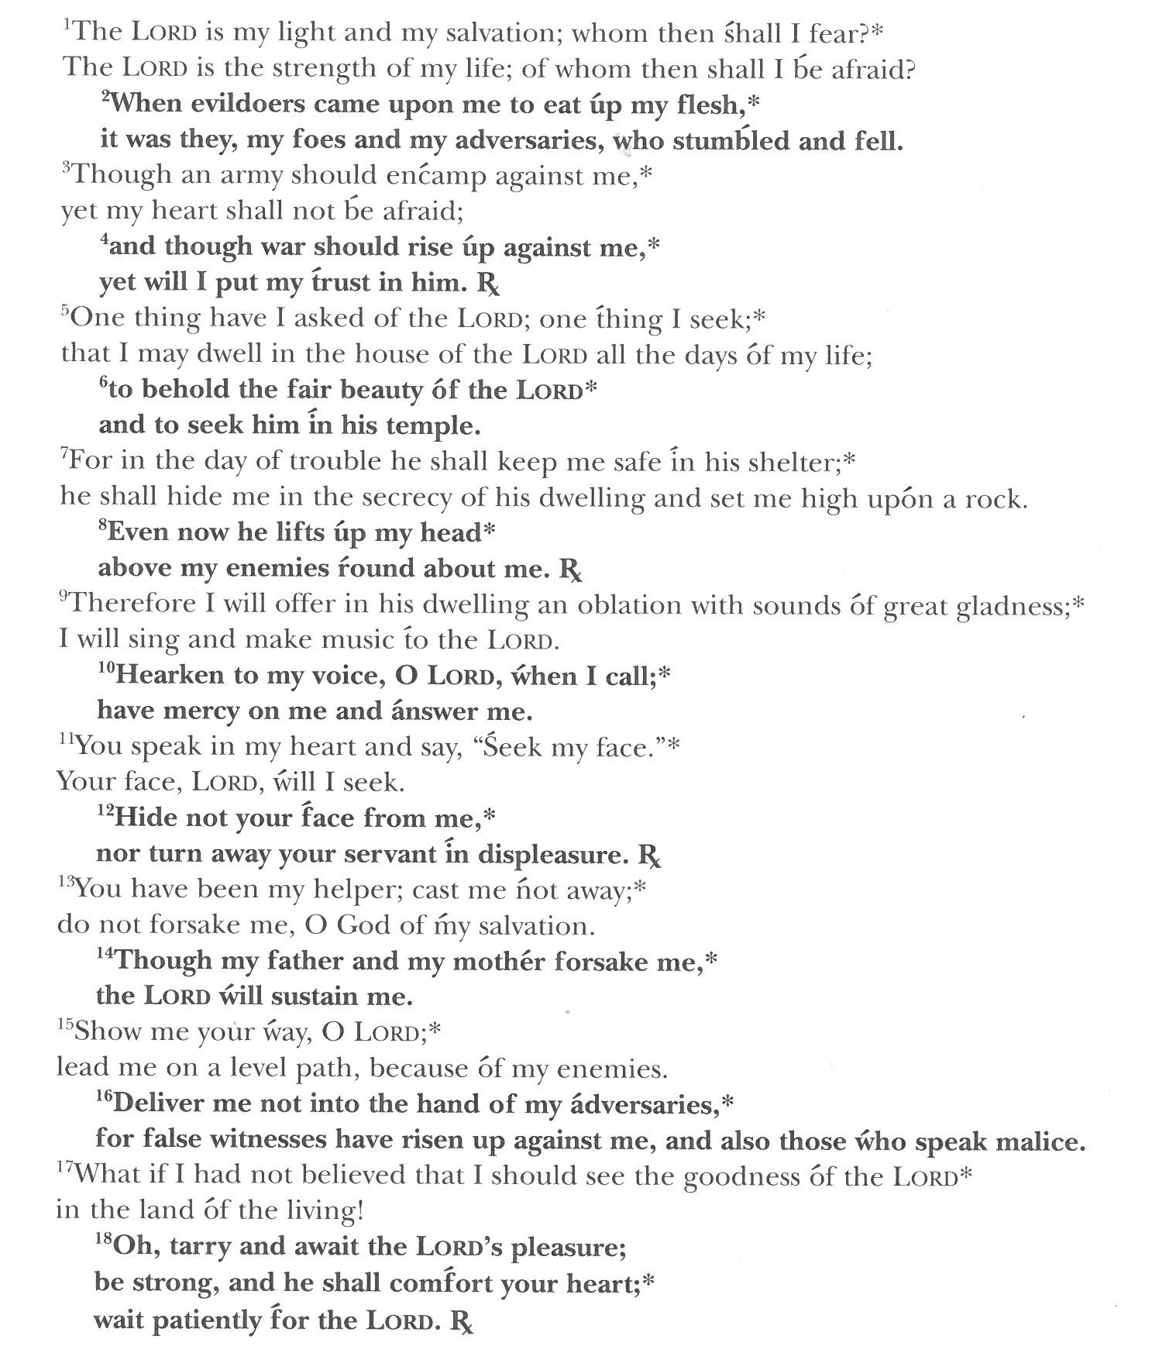
(The gospel is read by the pastor)
GOSPEL: Luke 13:31-35

Today’s gospel is found in the Thirteenth Chapter of the Book of Luke

Neither Herod’s plotting nor Jerusalem’s resistance to maternal love will deter Jesus from his sacrificial mission.

The gospel is announced.
The holy gospel according to St. Luke.
Glory to you, O Lord.

¹At that very hour some Pharisees came and said to him, “Get away from here, for Herod wants to kill you.” ³²He said to them, “Go and tell that fox for me, ‘Listen, I am casting out demons and performing cures today and tomorrow, and on the third day I finish my work. ³³Yet today, tomorrow, and the next day I must be on my way, because it is impossible for a prophet to be killed outside of Jerusalem.’ ³⁴Jerusalem, Jerusalem, the city that kills the prophets and stones those who are sent to it! How often have I desired to gather your children together as a hen gathers her brood under her wings, and you were not willing! ³⁵See, your house is left to you. And I tell you, you will not see me until the time comes when you say, ‘Blessed is the one who comes in the name of the Lord.’”

The gospel concludes:
The gospel of the Lord.
Praise to you, O Christ.

CHILDREN’S MESSAGE

HYMN OF THE DAY If You But Trust in God to Guide Your ELW 769., Vs 1, 3, 4

SERMON

PEACE
The peace of Christ be with you always.
And also with you.

(The pastor reads the introduction and the ending, the lay assistant reads the indented petitions.)
PRAYERS OF INTERCESSION

Seeking the grace, mercy, and love of Almighty God, we offer our prayers for the church, for people in need, and for all of creation.

God of Compassion, call your people to stand firm as citizens of heaven. Humble us by your wondrous love, and nurture mercy in our hearts and in our ministries.
Hear us, O God.
Your mercy is great.

Drown out the terror in the world with acts of lovingkindness and generosity. Release political leaders from pride and fear to act justly and serve their citizens.
Hear us, O God.
Your mercy is great.

Rush to answer those who cry out in times of trial, especially…. And all those for whom we now pray, either aloud in in our hearts.
Hear us, O God.
Your mercy is great.

Grant solace to people who long to be parents but have faced difficulty in bearing or adopting children. Build life-giving parent and child relationships for the sake of all.
Hear us, O God.
Your mercy is great.

Build up your holy community of saints through the works of church leaders and missionaries. Spread your word through your people for the sake of the world.
Hear us, O God.
Your mercy is great.

Reveal your will as you receive our prayers, and conform our ways to your ways, through the saving work of Jesus Christ our Lord.
Amen.

THANKSGIVING AT THE TABLE
In the night in which he was betrayed, our Lord Jesus took bread and gave thanks,
broke it, and gave it to his disciples, saying;
“Take and eat; this is my body, given for you. Do this for the remembrance of me.”

Again, after supper, he took the cup, gave thanks, and gave it for all to drink, saying;
“This cup is the new covenant in my blood, shed for you and for all people for the forgiveness of sin. Do this for the remembrance of me.”

Remembering, therefore, his life lived for others, and his death and resurrection which renews the face of the earth, we await his coming in glory.

Pour out upon us the Spirit of your love, O Lord, and unite the wills of all who share this heavenly food, the body and blood of Jesus Christ, our Lord; to whom, with you and the Holy Spirit, be all honor and glory, now and forever.
Amen.

LORD’S PRAYER
Gathered into one by the Holy Spirit, let us pray as Jesus taught us.

Our Father, who art in heaven, hallowed be thy name,
thy kingdom come, thy will be done, on earth as it is in heaven.

Give us this day our daily bread;
and forgive us our trespasses, as we forgive those who trespass against us;
and lead us not into temptation, but deliver us from evil.

For thine is the kingdom, and the power, and the glory, forever and ever.
Amen.

INVITATION TO COMMUNION
Return to God with all your heart.
Receive bread for the journey, drink for the desert.
Thanks be to God!

COMMUNION

(The prayer after communion is read by the lay assistant)
PRAYER AFTER COMMUNION

Compassionate God,
You have fed us with the bread of heaven. Sustain us in our Lenten pilgrimage;
may our fasting be hunger for justice, our alms, a making of peace,
and our prayer, the song of grateful hearts; through Christ our Lord.
Amen.

ANNOUNCEMENTS & OFFERING

Blessing
May God who has called us forth from the dust of the earth,
and claimed us as children of the light, strengthen you on your journey into new life.
Almighty God, Father, Son, + and Holy Spirit bless you, now and forever.
Amen.

Sending Song A Mighty Fortress is Our God (ELW 504)

(The dismissal is given by the lay assistant)
DISMISSAL
Marked with the cross of Christ,
Go forth to love and serve the Lord.
Thanks be to God!

Copyright © 2016 Augsburg Fortress. All rights reserved. Reprinted by permission under Augsburg Fortress Liturgies Annual License #SAS000806.
New Revised Standard Version Bible, copyright © 1989,
Division of Christian Education of the National Council of the Churches of Christ in the United States of America.
Used by permission. All rights reserved.

