Worship Plan for Maundy Thursday, March 29, 2018

CONFESSION AND FORGIVENESS

Friends in Christ,
in this Lenten season we have heard our Lord's call
to struggle against sin, death, and the devil—
all that keeps us from loving God and each other.
This is the struggle to which we were called at baptism.

Within the community of the church,
God never wearies of forgiving sin
and giving the peace of reconciliation.
On this night let us confess our sin against God and our neighbor,
and enter the celebration of the great Three Days
reconciled with God and with one another.

Silence is kept for reflection.

Most merciful God,
we confess that we are captive to sin
and cannot free ourselves.
We have sinned against you in thought, word, and deed,
by what we have done and by what we have left undone.
We have not loved you with our whole heart;
we have not loved our neighbors as ourselves.
For the sake of your Son, Jesus Christ,
have mercy on us.
Forgive us, renew us, and lead us,
so that we may delight in your will
and walk in your ways,
to the glory of your holy name. Amen.

In the mercy of almighty God,
Jesus Christ was given to die for us,
and for his sake God forgives us all our sins.
As a called and ordained minister of the church of Christ
and by his authority, I therefore declare to you
the entire forgiveness of all your sins,
in the name of the Father, and of the + Son,
and of the Holy Spirit.
Amen.

HYMN Softly and Tenderly Jesus is Calling (ELW 608)

GREETING
The grace of our Lord Jesus Christ, the love of God,
and the communion of the Holy Spirit be with you all.
And also with you.

Prayer of the Day

Let us pray.
Holy God, source of all love, on the night of his betrayal, Jesus gave us a new commandment, to love one another as he loves us. Write this commandment in our hearts, and give us the will to serve others as he was the servant of all, your Son, Jesus Christ, our Savior and Lord, who lives and reigns with you and the Holy Spirit, one God, now and forever.
Amen.

Adult Choir Anthem And No Bird Sang Douglas Wagner

(The first reading is read by the lay assistant)
THE FIRST READING: Exodus 12:1-4 [5-10], 11-14

A reading from Exodus
The LORD said to Moses and Aaron in the land of Egypt: ²This month shall mark for you the beginning of months; it shall be the first month of the year for you. ³Tell the whole congregation of Israel that on the tenth of this month they are to take a lamb for each family, a lamb for each household. ⁴If a household is too small for a whole lamb, it shall join its closest neighbor in obtaining one; the lamb shall be divided in proportion to the number of people who eat of it. ⁵Your lamb shall be without blemish, a year-old male; you may take it from the sheep or from the goats. ⁶You shall keep it until the fourteenth day of this month; then the whole assembled congregation of Israel shall slaughter it at twilight. ⁷They shall take some of the blood and put it on the two doorposts and the lintel of the houses in which they eat it. ⁸They shall eat the lamb that same night; they shall eat it roasted over the fire with unleavened bread and bitter herbs. ⁹Do not eat any of it raw or boiled in water, but roasted over the fire, with its head, legs, and inner organs. ¹⁰You shall let none of it remain until the morning; anything that remains until the morning you shall burn. ¹¹This is how you shall eat it: your loins girded, your sandals on your feet, and your staff in your hand; and you shall eat it hurriedly. It is the passover of the LORD. ¹²For I will pass through the land of Egypt that night, and I will strike down every firstborn in the land of Egypt, both human beings and animals; on all the gods of Egypt I will execute judgments: I am the LORD. ¹³The blood shall be a sign for you on the houses where you live: when I see the blood, I will pass over you, and no plague shall destroy you when I strike the land of Egypt.
¹⁴This day shall be a day of remembrance for you. You shall celebrate it as a festival to the LORD; throughout your generations you shall observe it as a perpetual ordinance.

The reading may be concluded:
Word of God, word of life.
Thanks be to God.

THE second READING: 1 Corinthians 11:23-26
A reading from First Corinthians
²³For I received from the Lord what I also handed on to you, that the Lord Jesus on the night when he was betrayed took a loaf of bread, ²⁴and when he had given thanks, he broke it and said, "This is my body that is for you. Do this in remembrance of me." ²⁵In the same way he took the cup also, after supper, saying, "This cup is the new covenant in my blood. Do this, as often as you drink it, in remembrance of me." ²⁶For as often as you eat this bread and drink the cup, you proclaim the Lord's death until he comes.

Word of God, word of life.
Thanks be to God.
Please stand to welcome the Gospel.

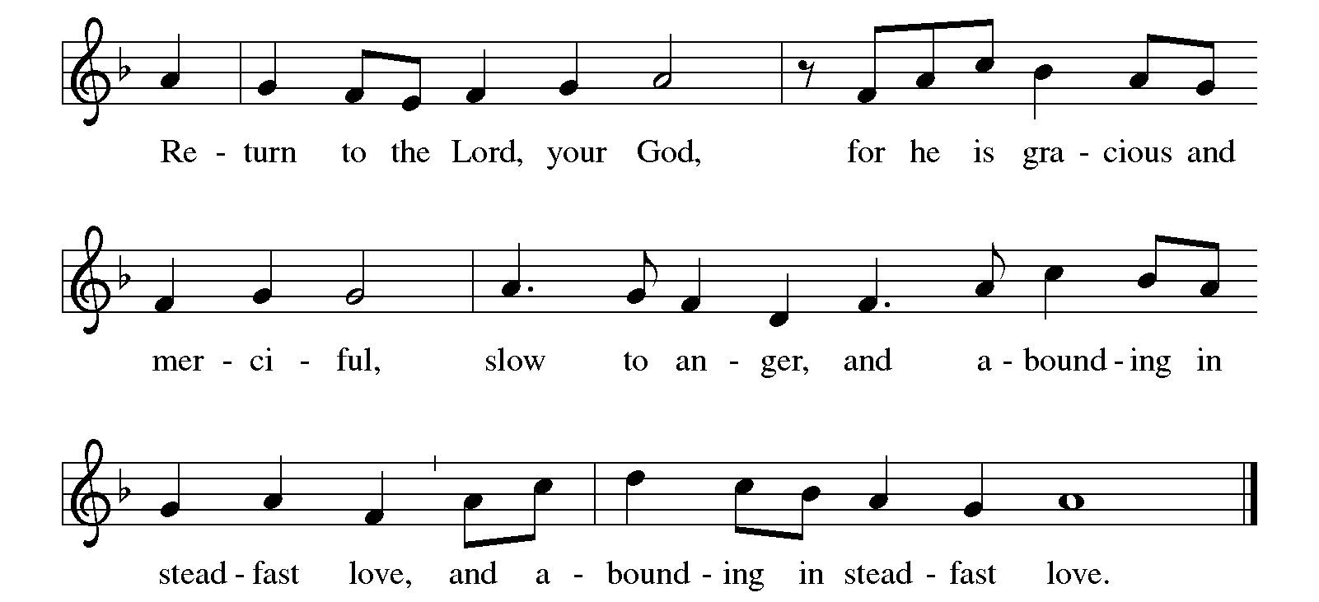

(The gospel is read by the pastor)
GOSPEL: John 13: 2b-14, 34-35

The gospel is announced.
The holy gospel according to John.
Glory to you, O Lord.

And during supper ³Jesus, knowing that the Father had given all things into his hands, and that he had come from God and was going to God, ⁴got up from the table, took off his outer robe, and tied a towel around himself.
⁵Then he poured water into a basin and began to wash the disciples' feet and to wipe them with the towel that was tied around him. ⁶He came to Simon Peter, who said to him, "Lord, are you going to wash my feet?"
⁷Jesus answered, "You do not know now what I am doing, but later you will understand." ⁸Peter said to him, "You will never wash my feet." Jesus answered, "Unless I wash you, you have no share with me." ⁹Simon Peter said to him, "Lord, not my feet only but also my hands and my head!"
¹⁰Jesus said to him, "One who has bathed does not need to wash, except for the feet, but is entirely clean. And you are clean, though not all of you." ¹¹For he knew who was to betray him; for this reason he said, "Not all of you are clean."
¹²After he had washed their feet, had put on his robe, and had returned to the table, he said to them, "Do you know what I have done to you? ¹³You call me Teacher and Lord — and you are right, for that is what I am. ¹⁴So if I, your Lord and Teacher, have washed your feet, you also ought to wash one another's feet. ³⁴I give you a new commandment, that you love one another. Just as I have loved you, you also should love one another. ³⁵By this everyone will know that you are my disciples, if you have love for one another."
The gospel concludes:
The gospel of the Lord.
Praise to you, O Christ.

THE MESSAGE

HYMN OF THE DAY Great God, Your Love Has Called us (ELW 358) V. 1, 3, 4

OFFERING AND WASHING

On this night we have heard our Lord's commandment to love one another as he has loved us. We who receive God's love in Jesus Christ are called to love one another, to be servants to each other as Jesus became our servant.
As our Lord Jesus modeled servanthood to his disciples by washing their feet, so too we will serve one another tonight by washing the hands of another.

Please use the center aisle to come to the front or back
of your section of pews.
Basins with warm soapy water and towels
are located at the front and back
of each section of pews.
A leader will be at each station to wash your hands and pray with you.
Offering plates are also situated at the ends of each aisle
so bring your offering with you as you participate.

The following prayer will be offered to each person.

Let us draw near to God with a sincere heart in full assurance of faith, having our hearts sprinkled to cleanse us from a guilty conscience and having our bodies washed with pure water. Let us hold unswervingly to the hope we profess, for he who promised is faithful. And let us consider how we may encourage one another on toward love and good deeds. (Hebrews 10:22-24)

THANKSGIVING AT THE TABLE
In the night in which he was betrayed, our Lord Jesus took bread and gave thanks,
broke it, and gave it to his disciples, saying;
“Take and eat; this is my body, given for you. Do this for the remembrance of me.”

Again, after supper, he took the cup, gave thanks, and gave it for all to drink, saying;
“This cup is the new covenant in my blood, shed for you and for all people for the forgiveness of sin. Do this for the remembrance of me.”

Remembering, therefore, his life lived for others, and his death and resurrection which renews the face of the earth, we await his coming in glory.

Pour out upon us the Spirit of your love, O Lord, and unite the wills of all who share this heavenly food, the body and blood of Jesus Christ, our Lord; to whom, with you and the Holy Spirit, be all honor and glory, now and forever.
Amen.

LORD’S PRAYER
Gathered into one by the Holy Spirit, let us pray as Jesus taught us.

Our Father, who art in heaven, hallowed be thy name,
thy kingdom come, thy will be done, on earth as it is in heaven.

Give us this day our daily bread;
and forgive us our trespasses, as we forgive those who trespass against us;
and lead us not into temptation, but deliver us from evil.

For thine is the kingdom, and the power, and the glory, forever and ever.
Amen.

INVITATION TO COMMUNION
Where charity and love abide, there is God.
Rejoice in this holy communion.
Thanks be to God!

COMMUNION

Prayer after communion (BY ASSISTING MINISTER)
Lord Jesus, in a wonderful sacrament you strengthen us
with the saving power of your suffering, death, and resurrection.
May this sacrament of your body and blood so work in us
that the fruits of your redemption will show forth in the way we live,
for you live and reign with the Father and the Holy Spirit,
one God, now and forever.

STRIPPING OF THE ALTAR

Depart in silence

Copyright © 2016 Augsburg Fortress. All rights reserved. Reprinted by permission under Augsburg Fortress Liturgies Annual License #SAS000806.
New Revised Standard Version Bible, copyright © 1989,
Division of Christian Education of the National Council of the Churches of Christ in the United States of America.
Used by permission. All rights reserved.

