Worship Plan for Easter Celebration Service
Sunday, April 21, 2019

PRELUDE

GATHERING SONG
Jesus Christ is Risen Today ELW 365

GREETING
Alleluia! Christ is Risen
He is risen indeed. Alleluia!

The grace of our Lord Jesus Christ,
the love of God, and the communion of the Holy Spirit be with you all.
And also with you.

CONFESSION & FORGIVENESS

Blessed be the holy Trinity, + one God,
The fountain of living water, The rock who gave us birth, Our light and our salvation.
Amen.

Let us come into the light, the revealing and healing light of God.

Silence is kept for reflection.
--
God of grace and glory,
you have brought us through the night of sin into the light of Jesus’ resurrection.
Yet our lives are still shadowed by sin.
Make us alive in Christ, O God. Make us new as you make all things new.
--
Rescue us from evil and the gloom of sin, renew us in grace, and restore us
to living in your holiness, through Jesus Christ, our risen Lord.
Amen.
--
Rejoice with all creation around God’s throne!
The light of the risen Christ puts to flight all evil deeds, washes away sin,
restores innocence to the fallen, casts out hate, brings peace, and humbles earthly pride.
--
Jesus Christ loves you and + frees you from your sins by his blood.
To him be glory and dominion forever and ever!
Amen.

ADULT CHOIR
Resurrection Chorus Jack Hayford

(The first reading is read by the lay assistant)
THE FIRST READING: Acts 10:34-43

A reading from the book of Acts.

³⁴ Then Peter began to speak to them: “I truly understand that God shows no partiality, ³⁵ but in every nation anyone who fears him and does what is right is acceptable to him.

³⁶ You know the message he sent to the people of Israel, preaching peace by Jesus Christ—he is Lord of all. ³⁷ That message spread throughout Judea, beginning in Galilee after the baptism that John announced:

³⁸ how God anointed Jesus of Nazareth with the Holy Spirit and with power; how he went about doing good and healing all who were oppressed by the devil, for God was with him.

³⁹ We are witnesses to all that he did both in Judea and in Jerusalem. They put him to death by hanging him on a tree; ⁴⁰ but God raised him on the third day and allowed him to appear,

⁴¹ not to all the people but to us who were chosen by God as witnesses, and who ate and drank with him after he rose from the dead.

⁴² He commanded us to preach to the people and to testify that he is the one ordained by God as judge of the living and the dead.

⁴³ All the prophets testify about him that everyone who believes in him receives forgiveness of sins through his name.”

The reading may be concluded:
Word of God, word of life.
Thanks be to God.

(The second reading is read by the lay assistant)
THE second READING: 1 Corinthians 15:19-26

A reading from Paul’s first letter to the church in Corinth.

¹⁹ If for this life only we have hoped in Christ, we are of all people most to be pitied.

²⁰ But in fact Christ has been raised from the dead, the first fruits of those who have died. ²¹ For since death came through a human being, the resurrection of the dead has also come through a human being;

²² for as all die in Adam, so all will be made alive in Christ. ²³ But each in his own order: Christ the first fruits, then at his coming those who belong to Christ.

²⁴ Then comes the end, when he hands over the kingdom to God the Father, after he has destroyed every ruler and every authority and power. ²⁵ For he must reign until he has put all his enemies under his feet.

²⁶ The last enemy to be destroyed is death.

The reading may be concluded:
Word of God, word of life.
Thanks be to God.

Please stand to welcome the Gospel.
GOSPEL ACCLAMATION:
Alleluia.
Lord, to whom shall we go?
You have the words of eternal life.
Alleluia. Alleluia.

(The gospel is read by the pastor)
GOSPEL: Luke 24:1-12

The gospel is announced.
The holy gospel according to Luke.
Glory to you, O Lord.

24 But on the first day of the week, at early dawn, they came to the tomb, taking the spices that they had prepared. ² They found the stone rolled away from the tomb,

³ but when they went in, they did not find the body. ⁴ While they were perplexed about this, suddenly two men in dazzling clothes stood beside them.

⁵ The women were terrified and bowed their faces to the ground, but the men said to them, “Why do you look for the living among the dead? He is not here, but has risen.

⁶ Remember how he told you, while he was still in Galilee, ⁷ that the Son of Man must be handed over to sinners, and be crucified, and on the third day rise again.” ⁸ Then they remembered his words,

⁹ and returning from the tomb, they told all this to the eleven and to all the rest. ¹⁰ Now it was Mary Magdalene, Joanna, Mary the mother of James, and the other women with them who told this to the apostles.

¹¹ But these words seemed to them an idle tale, and they did not believe them.

¹² But Peter got up and ran to the tomb; stooping and looking in, he saw the linen cloths by themselves; then he went home, amazed at what had happened.

The gospel concludes:
The gospel of the Lord.
Praise to you, O Christ.

CHILDREN’S MESSAGE

HYMN OF THE DAY
This is the Feast (ELW p. 140)

SERMON

PEACE
The peace of Christ be with you always.
And also with you.

THANKSGIVING AT THE TABLE
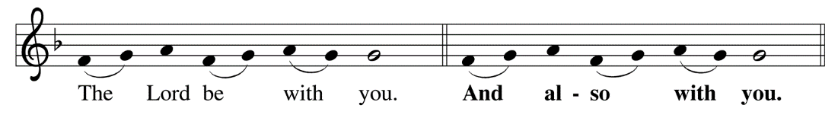
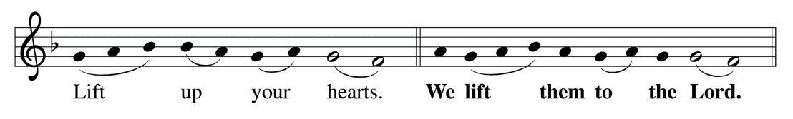
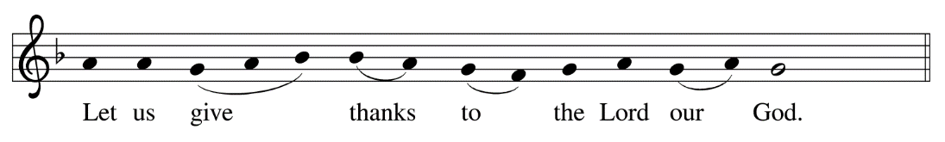
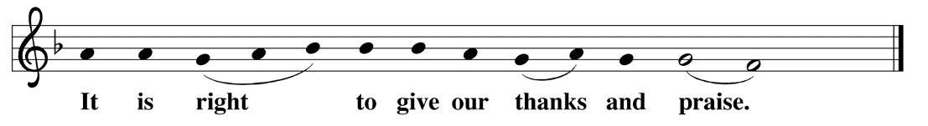

It is indeed right, our duty and our joy, that we should at all times and in all places
give thanks and praise to you, almighty and merciful God,
for the glorious resurrection of our Savior Jesus Christ,
the true Paschal Lamb who gave himself to take away our sin;
who in dying has destroyed death, and in rising has brought us to eternal life.
And so, with Mary Magdalene and Peter and all the witnesses of the resurrection,
with earth and sea and all their creatures, and with angels and archangels,
cherubim and seraphim, we praise your name and join their unending hymn:
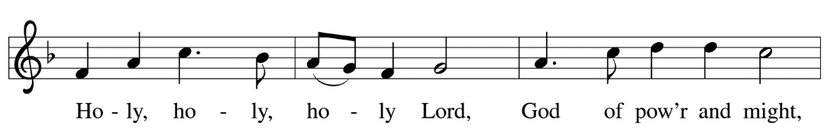

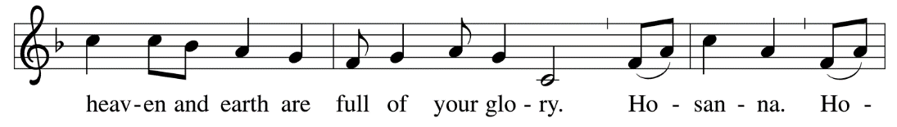

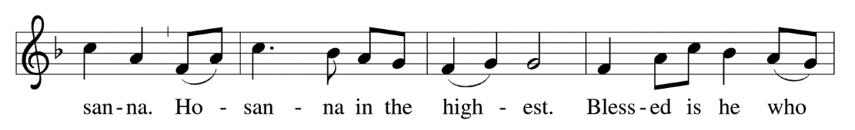

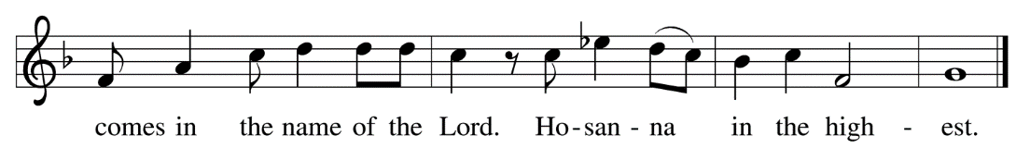

In the night in which he was betrayed, our Lord Jesus took bread and gave thanks,
broke it, and gave it to his disciples, saying;
“Take and eat; this is my body, given for you. Do this for the remembrance of me.”

Again, after supper, he took the cup, gave thanks, and gave it for all to drink, saying;
“This cup is the new covenant in my blood, shed for you and for all people for the forgiveness of sin. Do this for the remembrance of me.”
Amen.

LORD’S PRAYER
Gathered into one by the Holy Spirit, let us pray as Jesus taught us.

Our Father, who art in heaven, hallowed be thy name,
thy kingdom come, thy will be done, on earth as it is in heaven.

Give us this day our daily bread;
and forgive us our trespasses, as we forgive those who trespass against us;
and lead us not into temptation, but deliver us from evil.

For thine is the kingdom, and the power, and the glory, forever and ever.
Amen.

INVITATION TO COMMUNION
Jesus Christ, risen from the dead, gives everyone a place at the welcome table.
Alleluia! Thanks be to God!

COMMUNION

PRAYER AFTER COMMUNION
Life-giving God,
In the mystery of Christ’s death and resurrection
You send light to conquer darkness, water to give new life,
And the bread of heaven to nourish your people.

Send us forth as witnesses to Jesus’ resurrection
That we may show your glory to all the world;
Through the same Jesus Christ, our risen Lord.
Amen
ANNOUNCEMENTS & OFFERING

Blessing
May God who has brought us from death to life fill you with great joy.
Almighty God, Father, + Son, and Holy Spirit,
Bless you now and forever.
Amen.

Sending Song
Now All the Vault of Heaven Resounds (ELW 367)

(The dismissal is given by the lay assistant)
DISMISSAL
Go in peace. Serve the Risen Lord.
Thanks be to God.
Alleluia. Alleluia. Alleluia!

Copyright © 2016 Augsburg Fortress. All rights reserved. Reprinted by permission under Augsburg Fortress Liturgies Annual License #SAS000806.
New Revised Standard Version Bible, copyright © 1989,
Division of Christian Education of the National Council of the Churches of Christ in the United States of America.
Used by permission. All rights reserved.

